MZIMBA NORTH
FORM FOUR TERM ONE
HUMAN GEOGRAPHY PROVISIONAL MARKING KEY

Section A (75 marks)
1. a. (i) -Deep drilling mining (1 mark)
(ii) A- Natural gas (1 mark)
(iii) From the derrick, originate steel pipes which are connected to each other to the point
where oil is accessed. (1) A drill head called diamond cutter or bit (1) is fitted to the last
steel pipe. It is this diamond cutter or bit that cuts the rocks and soil until oil is reached
(1) and it is lubricated by mud mixed with water. (1) When oil has been accessed, it will
gush out naturally if under pressure, and if not, it has to be pumped. (1)
(5 marks)
(iv) -Pollution is associated with all activities throughout the stages of oil and gas
production.
-Waste waters, gas emissions, solid waste and aerosols generated during drilling
production, refining and transportation.
-cause acid rain as some petroleum products release a lot of sulphur dioxide and
nitrogen oxide that combine with rain water to form acid rain
-Intensification of greenhouse effect, acid rain, poor water quality, ground water
contamination.
-Loss of biodiversity and destruction of ecosystems.
- climate change is caused by burning of oils that release carbon dioxide
- land degradation caused by leaking pipelines that release oil spills
-fires and explosions as some petroleum products are highly flammable
(Any 2 points 1 mark each)

b. -Angola -Gabon -Libya
-Nigeria -Algeria (Any two, 2 marks)
c. (i) Generation of hydro-electrical power
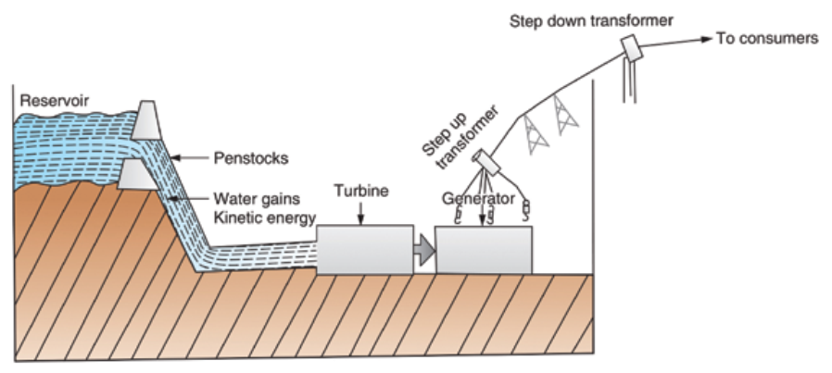

Water from a good height is directed through penstocks to rotate turbines. (1) The turbine is connected to a generator. (1) When the turbine rotates, the generator produces electricity (1)
(3 marks for the diagram, 3 marks for explanation)

(ii)-It is cheap as sunlight is free therefore fit for small scale or household purposes.
-Environmental friendly since it does not cause pollution / clean energy
-Unlimited supply, meaning the energy cannot be exhausted / Renewable
-It can be stored in batteries for later use.
-It requires minimal maintenance costs.
(Any two points-2 marks)

d. (i) -Encourages exploitation of new oil and coal fields in order to meet demand.
-Encourages alternative energy source usage hence energy development
-Encourages use of power saving devices
(2 points- 2 marks each)
(ii) -It uses non-renewable raw materials so it is not sustainable
-It is very expensive to produce and Malawi cannot afford.
-It is dangerous because any leak of radioactive materials can kill both plants and animals
-By-products from the energy production can be used to produce dangerous weapons such
as nuclear bombs

2. a. (i) 1: North eastern Atlantic/North Western Europe (1 mark)
2: South Africa (1 mark)
(ii) - rich planktons due to many rivers draining into it hence bringing nutrients
-harsh climate which hinder agriculture
-indented coastlines that provide breeding places for fish
-Large market of fish due to high demand
-Wide continental shelf where fish feed and breed in shallow waters
-Meeting of warm North Atlantic Drift and cold Canaries currents
(Any two points, 2 marks)
(iii) - Cod - Halibut - Herring - Salmon
- Sardine - Tuna - Mackerel
(Any 2 points, 1 mark)
b. (i) 1. - Air pollution / through burning
- Destruction of ozone layer / through release of harmful gases like CFCs
(Any one point, 2 marks)
2. - Reduces tourism / since it makes the environment unattractive/unhealthy
- Loss of recycling revenue / since there is no proper investment in recycling
and proper waste management
-Loss of potential investment and income due to existence of waste and bad smell
emitted which become unattractive to investors
(Any one point, 2 marks)
(ii) -Enhances public health by eliminating hazardous wastes.
-It helps to maintain clean and attractive environment
-Some wastes can be turned into organic manure
-It helps to prevent pollution in the environment
(Any 2 points-2 marks)
(iii) -It provides revenue through ecotourism.
-Source of employment through the tourism industry -Source of income for many people
(any 3 points, 1 mark each)

(c) (i) – it refers to the movement of people from urban areas to rural areas. 1mark
(ii) 1. -The establishment of industries results in the creation of more jobs.
-People are attracted to industries leading to urbanization.
(2marks)

2. When birth rate is higher in urban areas through natural growth, it contributes
greatly to urbanisation (2marks)

3. a. (i) -Unemployment
-Crime and prostitution
-Pollution
-Housing problems

(ii) -is treating discarded waste materials to make them suitable for subsequent reuse
(2 marks)
(iii) -conserve resources for future use
-reduce pollution
-save energy
-it supplies cheap goods
-create job in the correction transporting and storage
(Any two-2 marks)

b. (i) -Recycling, Resource recovery …..(in that order) (2 marks)
(ii) -is the classification of waste management strategies according to the desirability to
achieve optimal environmental outcomes (1 mark)
(iii) -avoidance / resource reduction (2 marks)
Reasons: - eliminate the need of handling wastes
-remove potential source of pollution

c. (i) -is an area of land whose soil is saturated with moisture permanently or seasonally
(2 marks)
(ii). Draw the Map of Malawi show three wetlands
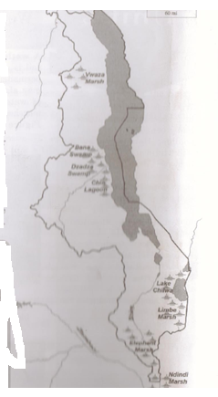

(5 marks)

(iii) -trapping sediments
-filter out pollutants from the run off
-absorbing nutrients taken by plants (2 marks)

d. (i) is the process of capturing and long term storage of carbon atmosphere
(2marks)
(ii) Lion, Leopard, Buffaloes, Elephants, Rhinos, Naphini, Mlombwa (3 marks)

SECTION B 25 MARKS
4. a. (i) 1. Densely populated -B
2. Sparsely populated -A
(ii) -poor infertile sandy soils which encourage leaching and retard farming
-harsh climate (hot and dry) not good for habitation
-Extremely high temperatures that cause discomfort
-unreliable and insufficient rainfall hinder settlement and farming
-difficult transport due to sand
(Any 2 points- 2 marks each)
(iii) -Rapid population growth exerts pressure on social service delivery leading to poor
quality services
-High unemployment leading to high crime
-Increased rate of crime which scares away investors.
-The government is economically strained due to the fact that its financial resources are
not adequate to cater for a growing population.
-Pressure on natural resources that leads to deforestation/overfishing/poaching/land,
water and air pollution
(Any 2 points- 1 mark each)

b. (i) Country A is wide based
-Because it has very high birth rates translating in to more young people (1 mark)
(ii) Country B has a narrow base.
-Because it has very low birth rates which means there are very few young people
(1 mark)
(iii) -Country B (2 marks)
(iv) -Because most of its population is adult and economically independent
(1 point 2 marks)
(v) -It implies that the country has a large population which is youthful hence less number
of people are economically independent
-has high dependency ratio hence poor / less economic development
c. 1. Stage two
-Birth rates remain high
-death rates fall due to improvements in health care and sanitation.
-birthrate and death rate are both the same
-Total population rises\expands
-population growth levels off
(any 2 points 1 mark) each
2. Stage four
-Birth rates are very low
-Death rates are very low
-Total population is very nearly stationary high
(any 2 points 1 mark each)
d.(i) - High birth rate
- Inadequate knowledge on family planning
- Poverty
(explain any two-4 marks)
(ii) - accessibility, it has good road network
- has rich agricultural land that attracts many people to settle there.

5. a. (i) -It refers to the measure showing number of dependents to economically active
population. (1 mark)
(ii) 1. Dependency ratio = number of dependants/working population x 100%
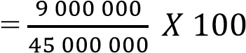 (1 mark)
=20% (2 marks)

2. The ratio means that for every 100 economically active people ¹ / there are 20
people depending on them ¹ / Thus, this is a relatively low dependency ratio¹.
(3marks)
b. -High levels of poverty resulting in high incidences of ill health
-Strain services and infrastructure by exerting pressure on the services
-Low quality of services due to high demand
-Increased crime rate leading to lack of peace and security
-Unemployment since supply of jobs exceeds demand
(any three points, 2 mark each)

c.(i) -This refers to the increase in the proportion of people living in towns and cities
(2 mark)
(ii) - It can lead to family break up
-Food production will decrease
-rural areas may experience insecurity
-they will be economic stagnation in the rural areas
(two points, 2 marks each)
d (i) -It is the technique of obtaining information about objects using special equipment that
are not in physical contact with the objects being investigated. Or it refers to the science
of acquiring information about an object or a phenomenon using equipment which is
not in physical contact with them
(2 marks)
(ii) 1. Transportation
Air traffic control uses remote sensing technology such as radar to track planes both on
the ground and in the air, and also to guide planes for smooth landings – Police also uses
radar to detect the speed of passing motorists

2. Epidemiology – Remote sensing and GIS technology can help epidemiologists
(people who study the pattern of disease development) recognize disease t rends or
outbreaks and link with their cause
(2 marks)

END OF THE MARKING KEY

